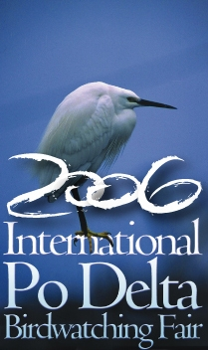


BIRDWATCHING LESSONS

From April 28th to April 30th 2006 Theoretical lessons

5.00 pm – 6.30 pm Teaching room LIPU
The LIPU course will be held by the ornithologist of international renown Menotti Passarella, founder of the telematic lists Birdingitaly and BW-Italia, as well as important point of reference as far as the Po Delta ornithology is concerned and who will be a member of the jury for the European Birdwatching race, held during the third edition of the International Po Delta Birdwatching Fair,Comacchio.
The LIPU corse will develop through a lesson in class, taking about 1 hour and in which the first rudiments will be given, and in the field classes where there will be the possibility to learn more about the acquired technics.
In particular, the following topics will be developed:
- the birdwatcher’s behaviour,
- equipment,
- clothing,
- observation and identification technics.
Among the indispensable equipments, the lead is held by a good binocular (from 7 to 10 magnification), a good guide to recognise birds and a notebook to write down one’s own observations, impressions and the experts’ advice. In a second step, it will be necessary to get equipped with a good binocular having the advantege of a high magnification power (from 20 to 60 times) and which will be able to be matched to a digital camera to get beautiful close shots.

Participants: max. 25 people for each theoretical lesson and from 15 to 30 people for the lesson in the field-see below- transport provided by the organisation. In case no seats will be left, it is possibile to participate with one’s own transportation.

April 29th –May 1st 2006 In the field lessons

April 29th: Valli di Ostellato (max. 15 people)
Partenza delle 10.00 – 13.30
Ore 10.30 Arrivo a Ostellato: escursione a piedi nelle Vallette
Ore 13.00 ritorno in pullman a Comacchio.

Monday May 1st: Valle Mandriole and Punte Alberete (max. 30 people)

11.00 am arrival at Valle Mandriole and birdwatching from the watch tower
1.00 pm transfer to Punte Alberete: walking excursion
5.30 pm return to Comacchio by pullman

For information and bookings
DELTA 2000 – Strada Luigia, 8 – San Giovanni di Ostellato (FE)
tel. 0533 57693, 0533 57694 - fax 0533 57674
e-mail: info@podeltabirdfair.it
sito web: www.podeltabirdfair.it

