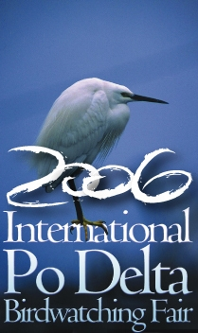
April 29th 2006
Experiencing Nature - Mesola and the Boscone*

6.30 pm departure to Mesola by pullman
7.15 pm visit to Mesola centre and to the Asparagus Festival, possibility of a typical dinner by the facilities in agreement with the Fair and by its pavilions (price not included)
8.30 pm transfer to Boscone della Mesola and excursion, where it will be possible to visit and listen to the night birds populating the Po Delta.
10.00 pm return to Comacchio by pullman (estimated arrival time: 11.00 pm)

Participants: max 25

* in event of non accessibility to the Boscone, the excursion will take place through Bosco di Santa Giustina

