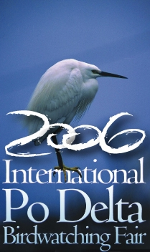
Sunday April 30th 2006
History and environment - Bagnacavallo: Pantaleone farm

6.30 pm Departure to Bagnacavallo (RA) by pullman
7.15 pm visit to the historic centre
8.30 pm Aperitiv in Bagnacavallo: welcome buffet offered by the Municipality Administration at Celti Centurioni farmhouse.
9.00 pm Transfer to Pantaleone farm and excursion: along the guided route you will have the chance to listen to the night wildfowl.
10.00 pm return to Comacchio by Pullman (estimated arrival time: 11.30 pm)

Participants: max 25

