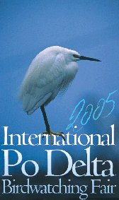
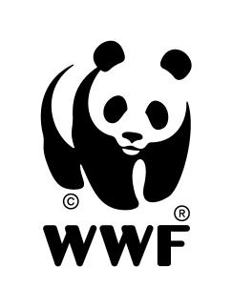WWF Italia Bureau of Education

Congress
Environmental Education meets Biodiversity

Comacchio April 29th 2005
Congress Room Pavilion A – International Po Delta Birdwacthing Fair
Comacchio (FE)

Diversity is a typical mark of all living beings. Understanding biological diversity is essential to understand life’s meaning, manifestations and functioning. Therefore, the concept of biodiversity is currently considered a key element of Biology, linked with other essential concepts to build the basis of a wide network of relationships responsible for most of the natural history of living beings. The concept of Biodiversity includes the diversity of all living beings, irrespective of their origins, and the ecological systems they belong to, in all their manifestations, as part of a global integrated vision based on complex, systemic networks.
Therefore the concept of Biodiversity expresses the complexity of life and environment and leads to the search for connections between the environment’s components, phenomena and times. Thus it acquires a high educational value in scientific terms, as well as in all learning processes aimed at understanding complexity.
Moreover, diversity is not only linked with science and knowledge, it also refers to different cultures, economy, ethics, morals, transcending the sphere of knowledge an touching upon values and behaviour.

The Bureau of Education of WWF Italia promotes an annual educational project for schools called Programme Panda Club. In 2004, the Bureau launched a three-year programme on sustainability, to deal with biological and cultural diversity in schools during the next school year 2005 - 2006.

The Congress offers the opportunity to present the educational project for schools, offering participants – mainly teachers and operators in the field of environmental education and training - a series of inputs, ideas and views on the relationship between environmental education and biodiversity.

Speeches by:
Elisabetta Falchetti – Zoological Museum of Rome
Fabrizio Bulgarini – Programme ERC Mediterranean WWF Italia
Marino Bonaiuto – University La Sapienza of Rome
Almo Farina – University of Urbino
Franco Zavalloni - GRTA – CIN of Cesena
Paolo Bortolami - Arpa Veneto
Marina Cinieri - Laboratorio Migrazioni of Genua
Marilena Salvarezza – Association Fratelli dell’uomo of Milan
Maria Antonietta Quadrelli – Bureau of Education WWF Italia

Times: from 10.30 a.m. to 4.30 p.m.

Free participation
More infos at www.wwf.it/educazione and www.podeltabirdfair.it

