Sponsored by:
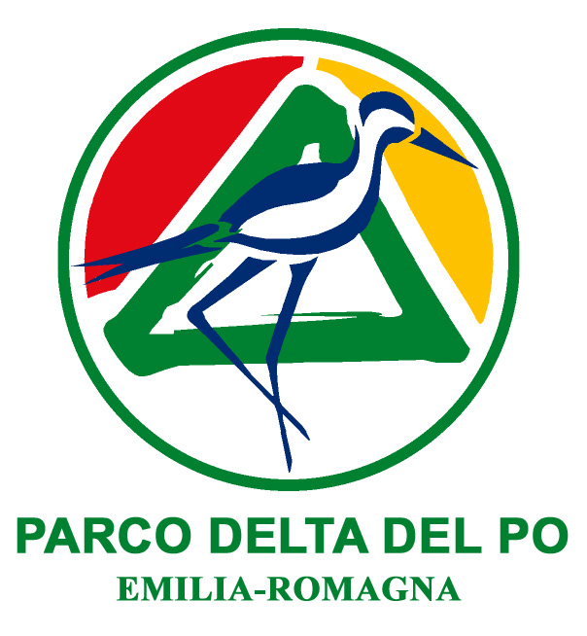
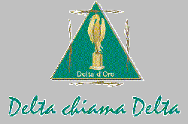

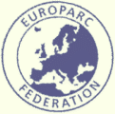
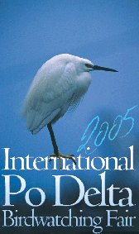

International Congress at the
International Po Delta Birdwatching Fair 2005
Comacchio

INVITATION

”UPDATING BIRD HERITAGE”
Scientific research and projects to monitor and safeguard birds in European Protected Areas

Palazzo Bellini – Comacchio (FE)
Thursday April 28th 2005

GOALS:
The international Congress, which will take place in Comacchio on April 28th, on the opening day of the International Po Delta Birdwatching Fair, will focus on European experiences in research, monitor and management for the conservation of waterfowl in protected wetlands. The Congress is sponsored by Federparchi, Europarc Italia, Delta chiama Delta and the Po Delta Park of the Region Emilia Romagna. During the morning session, experts from different European countries will talk about their national experiences, in order to build an overview of the current European situation and state of the art. The objective is to identify the operational approach resulting from research studies, which will then be adopted to create a biological station in the Po Delta Park. The aim is to share the knowledge resulting from research and monitoring for conservation, while promoting correct information and tourist use of protected areas. The speeches of the afternoon will therefore deal with experiences in managing protected areas, with significant Italian and European contributions, as well as the actions carried out by international bodies.

TARGET:
Institutions and Boards for the Conservation of Protected Areas
Public Administration
Environmental Associations
Specialised Tour operators
Sponsored by:

International Congress at the
International Po Delta Birdwatching Fair 2005
Comacchio

”UPDATING BIRD HERITAGE”
Scientific research and projects to monitor and safeguard birds in European Protected Areas

PROGRAMME
Thursday April 28th 2005
Palazzo Bellini – Comacchio (FE)

9.30 a.m. Opening session
Welcome speeches

Introduction Valter Zago / President of the Po Delta Park of the Region Emilia-Romagna

10.30 a.m. Speeches
Research programmes, conservation biology, strategic promotion
Chairman Tobias Salathé / Ramsar Bureau
- Tobias Salathé / Ramsar Bureau
the ramsar convention from 1971 to 2005
- Mike Smart / IUCN Mediterraneo
The contribution of applied research to the CONSERVATION of the mediterranean Fernando Spina / INFS
Monitoring through research on migratory flows
- Josè Juan Chans Pousada /Estacion Biologica de Donana – CISC
Action programmes of the biological station of donana
- Franco Ferroni / Wwf Italia
“ECO-REGIONAL CONSERVATION AND ECOLOGICAL NETWORKS FOR MANAGEMENT AND CONSERVATION OF WETLANDS
- Francesco Mezzatesta /Parco Delta Po Emilia-Romagna
PROMOTION OF BIRDWATCHING AS CONSERVATION FACTOR
Arnaud Bechet – Alan Johnson/ Tour du Valat
PIONEER EXPERIENCES OF THE BIOLOGICAL STATION OF tour du valat
Debate
1.00 p.m./2.30 p.m. Buffet

3.00 p.m. Speeches
Experiences in managing waterfowl in the network of European protected areas
Chairman Fernando Spina/ INFS
- Emiliano Verza /Veneto Regional Park of the Po Delta
- Massimiliano Costa / Emilia Romagna Regional Park of the Po Delta
- Nicola Baccetti/ Wetlands International
- Ariel Brunner /Lipu Rete Natura 2000
- Xavier Abril i Ferrer / Natural Park of the Ebro Delta
- Franca Zanichelli / Regional Park of the River Taro
- Virgil Munteanu / Reserve of the Biosphere of the Danube Delta

5.00 p.m. Conclusions

